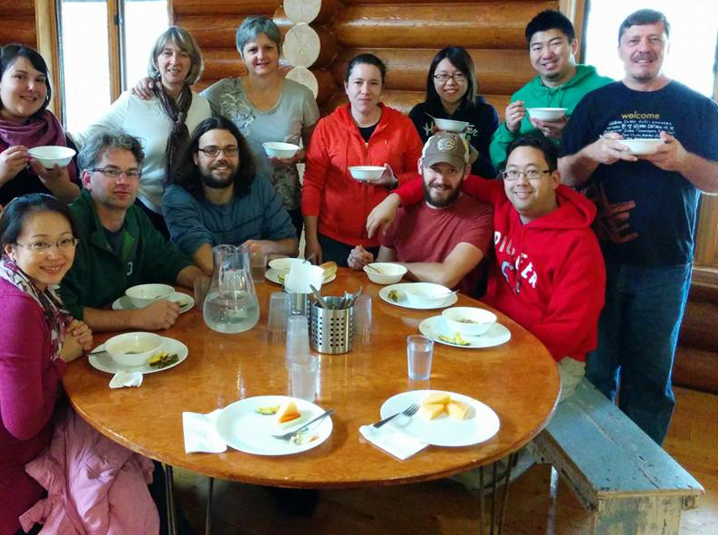

To do this work, **I AM COMMITTED TO RAISING $XX,XXX** on behalf of Inter-Varsity Christian Fellowship’s mission.

You may not be able to go physically to the front lines of youth culture. But you can go with us in significant ways. Will you become partners with us in reaching young people today?

**WILL YOU COMMIT TO:**

• Praying for us

• Giving Financially

• Volunteering time



**CAMP AND CAMPUS MINISTRIES SHAPED MY COMMITMENT TO FOLLOWING JESUS**

My cousin first invited me to summer camp when I was about nine years old. I loved it so much that the next year I invited friends to come with me and when I was old enough, I became summer staff.

Camp changed me. I made friends with kids who came from different background than mine. I discovered I could do things I thought impossible – like hitting a baseball further than left field. Most importantly, I learned God loved me – and my friends, too.

My parents sent me to Urbana 79 when I was a first-year university student. That was a pivotal experience for me – introducing me to thousands of young people who were fervent followers of Jesus. I began to see how I could be bolder in my faith.

**Andrew Morinaga**

Graphic Designer